Exploring how climate will impact plant-insect distributions
and interactions using open data and informatics

- Mac and PC Instructions for Downloading Git -

To download Git on a Mac
- Go to git-scm.com
- On the right-hand side of the screen click ‘Download 2.14.1 for Mac’; note the version may have changed since this was written. If that’s the case, the version you download will be higher than 2.14.1, but should work regardless.
- If your download does not start automatically you can choose ‘click here if download does not start automatically’ on this screen. This will bring you to a new screen where the download will begin.
- Open what you just downloaded from your Downloads folder. Double click the installer (probably the file labeled – git-2.14.1-intel-universal-mavericks.pkg; note if you downloaded a more recent version of Git, “2.14.1” will be replaced with that version number)
- If you are working on a Mac you may get a security warning like the following: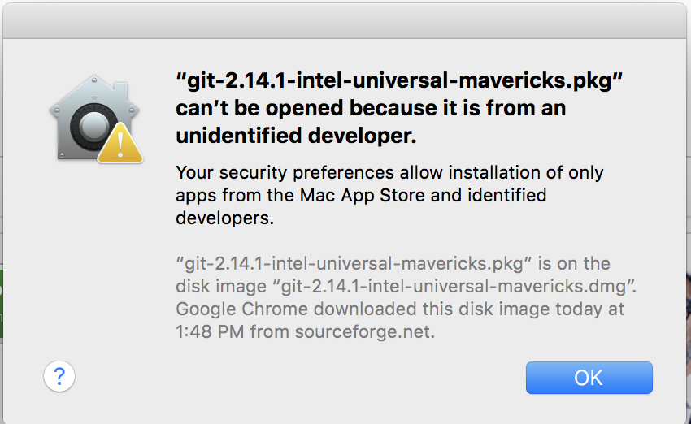
If this happens, click ok. Then open your system preferences folder (click the apple icon in the upper-left-hand corner of the screen. Click on ‘Security and Privacy’ from the top row. At the bottom of the window you will see a message saying ‘git-2.14.1-intel-universal-mavericks.pkg was block from opening because it is not from an identified developer’ – next to it you will see a button that says ‘Open Anyway’. Click Open Anyway and close the window.
- If the git installation window doesn’t automatically open, follow the instructions in step 4 to open the window.
- Follow the instructions in the wizard to install git. This program should now be in your applications menu or in /usr/local/bin/git, which can be accessed through a Terminal window.

To download Git on a PC
- Go to git-scm.com
- On the right-hand side of the screen click ‘Download for Windows’ (the image of the computer will likely have the details of your operating system).
- One the next screen click the link for the ’64-bit Git for Windows Setup’
- Open the file you download
- Follow the prompt of the installation wizard and choose the default settings.

